FINANCIAL TRANSACTION & LOANS DASHBOARD
POWER BI PROJECT REPORT

S.JENNIFER
E25FA015
B.COM FINTECH AND AI

1. INTRODUCTION
The Financial Transaction & Loans Dashboard is a business intelligence project developed in Microsoft Power BI. It brings together information about customers, account types, account status, loans and financial transactions. The dashboard converts data from multiple tables into a visual summary that can be understood by students, analysts and management.
The dashboard shown in Figure 1 contains four headline cards, account-type analysis, a loan-status donut chart, a transaction summary table, a monthly transaction trend and a transaction-type comparison. These visuals help users monitor activity and identify areas that may need attention.
The monetary values in the supplied screenshot are displayed with a dollar sign ($). This report retains the dashboard's displayed currency and does not convert the amounts.
2. OBJECTIVES
To present key financial information in one consolidated dashboard.
To monitor customer volume and active customer accounts.
To analyse transaction values and transaction counts by transaction type.
To review loan status, including active, paid-off and overdue loans.
To compare account categories and observe monthly transaction patterns.
To support clear reporting and informed business decisions.

3. DATASET DESCRIPTION
The Power BI Data pane in the supplied screenshot shows a model organised into related tables. The table names indicate that the dataset covers customer details, accounts, loans, branches, addresses and transactions.
Table Name | Purpose in the Analysis
Customers | Customer information used for customer-level analysis.
Customer Types | Categories used to classify customers.
Accounts | Account records linked to customers and account types.
Account Types | Account categories such as Youth, Business, Savings, Payroll and Checking.
Account Statuses | Status categories used to describe account conditions.
Transactions | Individual financial transaction records.
Transaction Types | Categories such as Deposit, Payment, Transfer and Withdrawal.
Loans | Loan records associated with customers or accounts.
Loan Statuses | Loan conditions such as Active, Paid Off and Overdue.
Loan Types | Categories describing the types of loans offered.
Branches | Branch-related information for organisational or location analysis.
Addresses | Address details associated with relevant records.
Note: The screenshot confirms the table names, but it does not show every column or the relationship diagram. The descriptions above explain the likely analytical role of each table based on its name; confirm the exact fields and relationships in Model view before final submission.
4. DATA PREPARATION
Data preparation is required before creating reliable calculations and visuals. The following workflow is recommended for the tables used in this dashboard:
Import the dataset: Use Home → Get data to connect to the source files or database.
Review tables and columns: Check table names, data types, column names and whether the expected records are present.
Clean the data: Remove unnecessary blank rows, correct inconsistent labels and review duplicate records.
Handle missing values: Identify null or missing customer, account, loan and transaction fields; resolve them using suitable business rules.
Set data types: Set dates as Date, monetary fields as Decimal Number or Fixed Decimal Number, and identifiers to appropriate text or whole-number types.
Create relationships: Connect fact tables such as Transactions and Loans to relevant lookup tables using valid keys. Confirm relationship cardinality and filter direction.
Validate totals: Compare transaction counts and monetary totals with the source data before publishing visuals.
Apply changes: Select Close & Apply in Power Query to load the prepared data into the Power BI model.

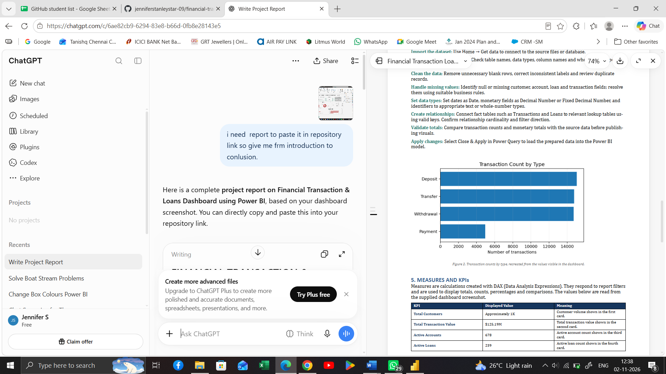

5. MEASURES AND KPIs
Measures are calculations created with DAX (Data Analysis Expressions). They respond to report filters and are used to display totals, counts, percentages and comparisons. The values below are read from the supplied dashboard screenshot.
KPI | Displayed Value | Meaning
Total Customers | Approximately 1K | Customer volume shown in the first card.
Total Transaction Value | $125.19M | Total transaction value shown in the second card.
Active Accounts | 678 | Active account count shown in the third card.
Active Loans | 239 | Active loan count shown in the fourth card.
Suggested DAX measure patterns
The exact column names are not visible in the screenshot. These are templates only; replace table and column names with the exact names in your model and check the results against the source data.
Total Transaction Value
Total Transaction Value = SUM(Transactions[TransactionAmount])
Total Transactions
Total Transactions = COUNTROWS(Transactions)
Total Customers
Total Customers = DISTINCTCOUNT(Customers[CustomerID])
Active Accounts
Active Accounts = CALCULATE(DISTINCTCOUNT(Accounts[AccountID]), 'Account Statuses'[StatusName] = "Active")
Active Loans
Active Loans = CALCULATE(DISTINCTCOUNT(Loans[LoanID]), 'Loan Statuses'[StatusName] = "Active")

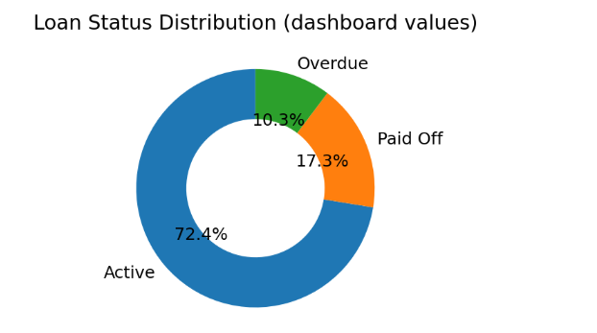

The percentages total approximately 100% (small difference may occur because of rounding). The donut chart shows a total of 330 loans: approximately 239 active, 57 paid off and 34 overdue. These counts are inferred from the displayed percentages and total, so they should be checked against the underlying data.
6. DASHBOARD COMPONENTS

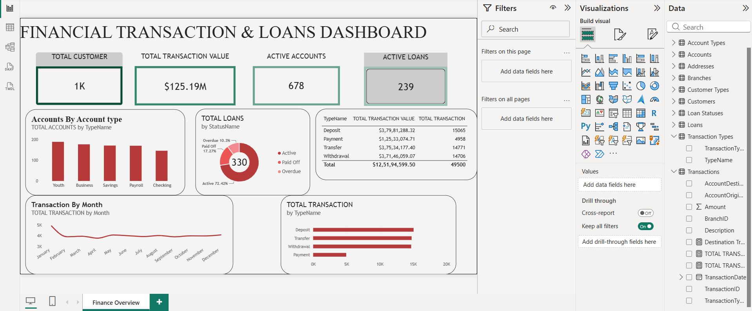

KPI Cards: Show headline measures: total customers, transaction value, active accounts and active loans.
Accounts by Account Type: A column chart compares the number of accounts across Youth, Business, Savings, Payroll and Checking.
Total Loans by Status: A donut chart shows the share of active, paid-off and overdue loans.
Transaction Summary Table: A table displays transaction value and transaction count for Deposit, Payment, Transfer and Withdrawal.
Transaction by Month: A line chart displays the month-wise transaction pattern from January to December.
Total Transaction by Type: A horizontal bar chart compares transaction counts across transaction types.

7. FINDINGS AND INTERPRETATION
The dashboard reports approximately 1K customers and 678 active accounts.
The total transaction value displayed is approximately $125.19M.
The active-loan card shows 239 active loans.
The loan-status chart indicates that active loans form the largest share at 72.42%.
The transaction summary shows deposits with the highest displayed transaction count (15,065), followed by transfers (14,771), withdrawals (14,706) and payments (4,958).
The monthly line chart provides a year-wide view, which can help users notice changes in transaction activity.
Management can use these observations to review overdue loans, monitor account activity and investigate unusual changes in transaction volumes. The dashboard supports monitoring; it does not by itself prove why a trend occurred.
8. CONCLUSION
The Financial Transaction & Loans Dashboard demonstrates how Microsoft Power BI can convert financial data into clear and useful visual information. It combines customer, account, loan and transaction analysis in one report. The KPI cards provide a quick summary, while charts and tables help users compare categories and observe patterns.
Overall, the dashboard can support financial monitoring, reporting and management decision-making. Its accuracy depends on correct data preparation, valid table relationships and properly tested DAX measures.

